**Assignment - 1**

1. **Create a first ASP.NET Website and execute it on web browser.**

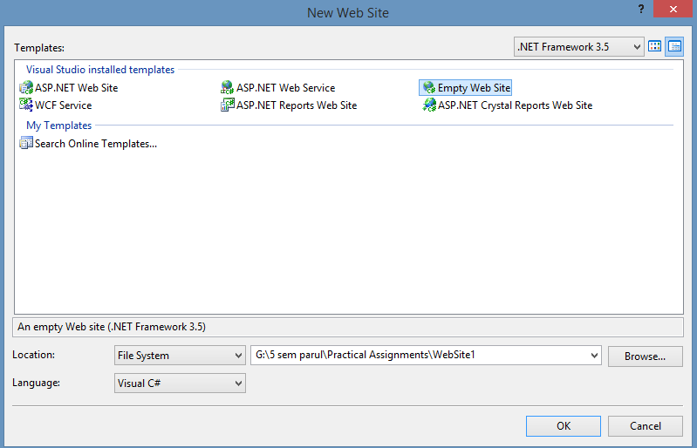

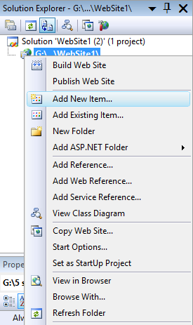

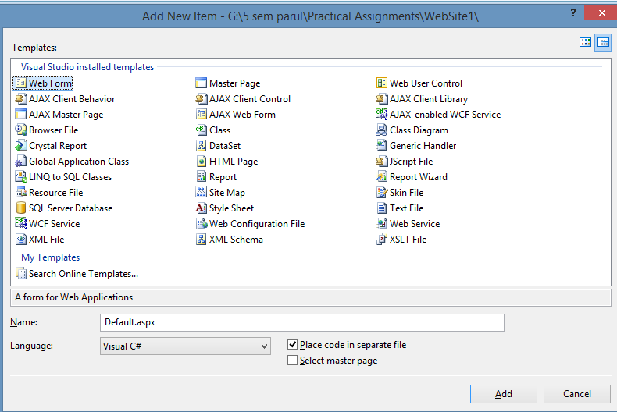

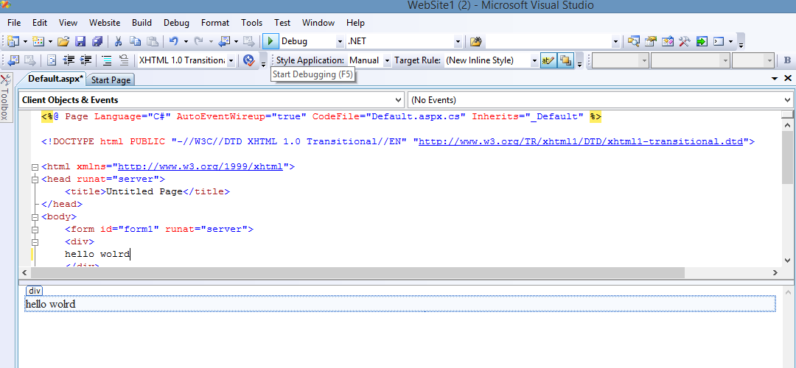

1. **Write ASP.NET program that will display “Hello World” on page load event.**

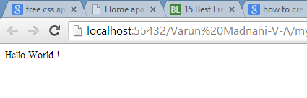

Code :

protected void Page_Load(object sender, EventArgs e)

{

Response.write(“Hello World ! “);

}

1. **Write ASP.NET program that will display “Hello World” in Label control on form load event.**



Design :

<body>

<form id="form1" runat="server">

<div>

<asp:label ID="Label1" runat="server" text="Label"></asp:label>

</div>

</form>

</body>

Code :

protected void Page_Load(object sender, EventArgs e)

{

Label1.Text = "Hello World !";

}

1. **Write ASP.NET program that will display “Hello World” in <div> tag or <p> tag on click of button.**

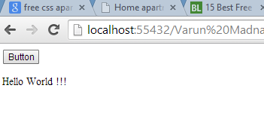

**Design:**

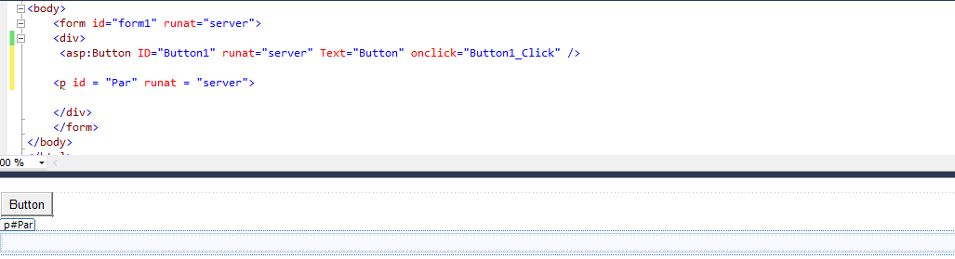

**Code:**

protected void Button1_Click(object sender, EventArgs e)

{

Par.InnerText = "<b><u>Hello World !!!</u></b>";

}

1. **Write ASP.NET program that will do following operations:**

* **Take two string values from textbox control, contcate it & display it.**

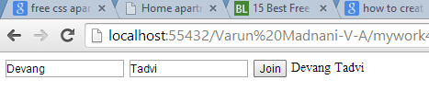

**Design:**

<body>

<form id="form1" runat="server">

<div>

<asp:TextBox ID="TextBox1" runat="server"></asp:TextBox>

<asp:textbox ID="Textbox2" runat="server"></asp:textbox>

<asp:Button ID="Button1" runat="server" Text="Join" OnClick = "Button1_Click" />

<asp:Label ID="Label1" runat="server" Text=" "></asp:Label>

</div>

</form>

</body>

**Code:**

protected void Button1_Click(object sender, EventArgs e)

{

Label1.Text = TextBox1.Text + Textbox2.Text;

}

- Take two int values and calculate addition.

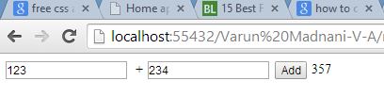

**Design:**

<body>

<form id="form1" runat="server">

<div>

<asp:TextBox ID="TextBox1" runat="server"></asp:TextBox> &nbsp;+

<asp:TextBox ID="TextBox2" runat="server"></asp:TextBox>

<asp:Button ID="Button1" runat="server" Text="Add" onclick="Button1_Click" />

<asp:Label ID="Label1" runat="server" Text=""></asp:Label>

</div>

</form>

</body>

**Code:**

protected void Button1_Click(object sender, EventArgs e)

{

int a, b, c;

a = Convert.ToInt32(TextBox1.Text);

b = Convert.ToInt32(TextBox2.Text);

c = a + b;

Label1.Text = Convert.ToString(c);

}

1. **Write ASP.NET program that will take two int values &calculate a^b.**



Design:

<form id="form1" runat="server">

<div>

<asp:TextBox ID="TextBox1" runat="server"></asp:TextBox>

<asp:TextBox ID="TextBox2" runat="server"></asp:TextBox>

<asp:Button ID="Button1" runat="server" Text="Result" onclick="Button1_Click" />

<asp:Label ID="Label1" runat="server" Text=""></asp:Label>

</div>

</form>

Code:

protected void Button1_Click(object sender, EventArgs e)

{

double a, b, c;

a = Convert.ToInt32(TextBox1.Text);

b = Convert.ToInt32(TextBox2.Text);

c = Math.Pow(a, b);

Label1.Text = TextBox1.Text + "^"+TextBox2.Text+" = "+ Convert.ToString(c);

}

1. **Write ASP.NET program that will take 3 subject marks & find Total & Average.**

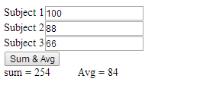

Design:

<div>

<asp:Label ID="Label1" runat="server" Text="Subject 1">

<asp:TextBox ID="TextBox1" runat="server"></asp:TextBox><br />

<asp:Label ID="Label2" runat="server" Text="Subject 2"></asp:Label><asp:TextBox ID="TextBox2"

runat="server"></asp:TextBox><br />

<asp:Label ID="Label3" runat="server" Text="Subject 3"></asp:Label><asp:TextBox ID="TextBox3"

runat="server"></asp:TextBox><br />

</asp:Label>

<asp:Button ID="Button1"

runat="server" Text="Sum & Avg" onclick="Button1_Click" />

<br />

<asp:Label ID="Label4" runat="server" Text="Label"></asp:Label>&nbsp;&nbsp;&nbsp;&nbsp;&nbsp;&nbsp;&nbsp;&nbsp; <asp:Label ID="Label5"

runat="server" Text="Label"></asp:Label>

</div>

Code:

protected void Button1_Click(object sender, EventArgs e)

{

int sum = int.Parse(TextBox1.Text) + int.Parse(TextBox2.Text) + int.Parse(TextBox3.Text);

float avg = sum/3;

Label4.Text = "sum = " + sum.ToString();

Label5.Text = "Avg = " + avg.ToString();

}

1. **Create ASP.NET Webpage that will take feedback details from user and Display it as testimonial. Feedback : Name, email and feedback desc.**

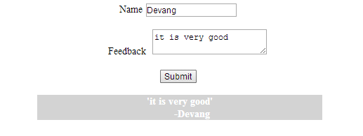

Design:

<form id="form1" runat="server">

<div>

<center>

<asp:Label ID="Label1" runat="server" Text="Name"></asp:Label>

<asp:TextBox ID="TextBox1" runat="server"></asp:TextBox>

<br /><br />

&nbsp;&nbsp;&nbsp;&nbsp;&nbsp;&nbsp;

<asp:Label ID="Label3" runat="server" Text="Feedback"></asp:Label>

&nbsp;<asp:TextBox ID="TextBox3" runat="server" TextMode="MultiLine"></asp:TextBox>

<br /><br />

<asp:Button ID="Button1" runat="server" Text="Submit" onclick="Button1_Click" />

<br /><br />

<div id="tes" style="width:30%;background-color:lightGray;color:white;font-weight:bold" runat="server">

</div>

</center>

</div>

</form>

Code:

protected void Button1_Click(object sender, EventArgs e)

{

string fed = "'" + TextBox3.Text +"'";

fed += "<br>&nbsp;&nbsp;&nbsp;&nbsp;&nbsp;&nbsp;&nbsp;&nbsp; -" + TextBox1.Text;

tes.InnerHtml = fed;

}

1. **Create ASP.NET Webpage that will upload any file to webserver.**

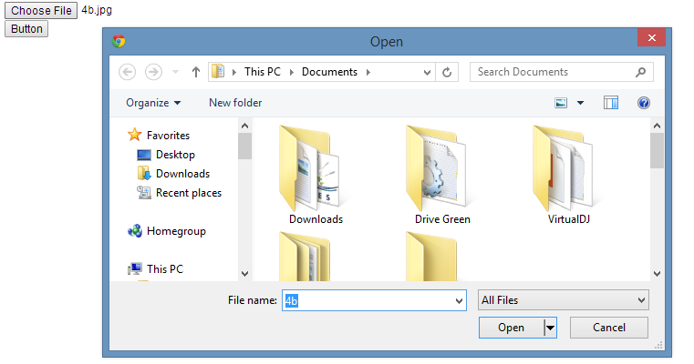

Design:

<form id="form1" runat="server"><div>

<asp:Label ID="Label1" runat="server" Text="Label"></asp:Label>

<br />

<asp:fileupload ID="Fileupload1" runat="server"></asp:fileupload>

<br />

<asp:Button ID="Button1" runat="server" Text="Button" onclick="Button1_Click"

PostBackUrl="~/Default.aspx" />

<p id="par" runat="server" ></p>

</div>

</form>

Code:

protected void Page_Load(object sender, EventArgs e)

{

}

protected void Button1_Click(object sender, EventArgs e)

{

if (Fileupload1.HasFile)

{

try

{

string filename = Path.GetFileName(Fileupload1.FileName);

Fileupload1.SaveAs(Server.MapPath("~/") + filename );

Label1.Text = "Upload status: File uploaded!";

}

catch (Exception ex)

{

Label1.Text = "Upload status: The file could not be uploaded. The following error occured: " + ex.Message;

}

}